**Description of the model**

For the purpose of the assignment - Luxury Cruises Company was allocated to the Group F.

In order to come up with the database model, we first defined business rules, which are quite close to the real life scenarios (although none of the team members have actually been on a cruise in real life :D).

To be more specific, the business process explanation is as follows.

* A client can use one of the following channels to obtain a ticket on a cruise:
  + A third party agency offices;
  + Official / local office of the company;
  + Third party websites, e.g. booking.com, expedia.com, etc
* Once the client chooses which route to go on, each route has specific date/time and the price;
* In addition to the cruise chosen, a client shall also choose room type & category (i.e. single deluxe room, double suite room, etc);
* The total ticket price is calculated by adding route price to the room price.

Once the client is on-board, the client may want to use additional services such as cafes, restaurants, cinemas, beauty salons, spa salons, casinos, and so on. Onboarding sales are captured in a separate table “onboarding_sales” (for aggregated sales) along with “sales_item” table (for sales listing each item that is referenced to the “onboarding_sales”).

Every single item has a specific category, class, family and segment assigned to it. In addition, tables have been split into several smaller parts in order to ensure the maximum possibility of atomic (indivisible) attributes.

How to read ERD schema (summary of the model is shown below):

1. Start with Ticket table. This is the centre hub of our information.
2. 3 important tables directly related to the Ticket table are: passengers, rooms, and routes
   1. Passengers: this contains the information of our customers, associated with address, zipcode, etc
   2. Rooms: since our sales is based on room price and route price, room tables contains the type, price, currency information for further sales calculation
   3. Routes: since our sales are based on room price and route price, contains the information of the ship itself and route price. In addition, service sales are also associated with routes.
      1. Sales: since all sales are attached to routes, sales tables (onboard_sales, sales_item, and item) contain information about the stores and item categories. It also links with currency and payment table as we need currency information to accept different currencies.

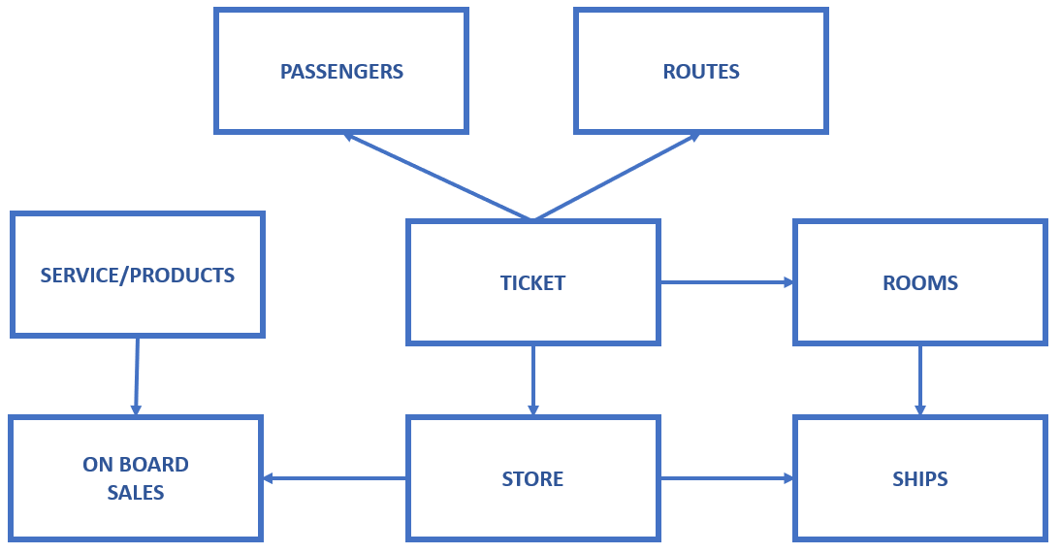

**Cruise Data Model**